How to reset a device to factory?
Method 1:
Step 1: Open the browser and input plc.tendawifi.com in address bar to login setup page. By default, password is “admin”.
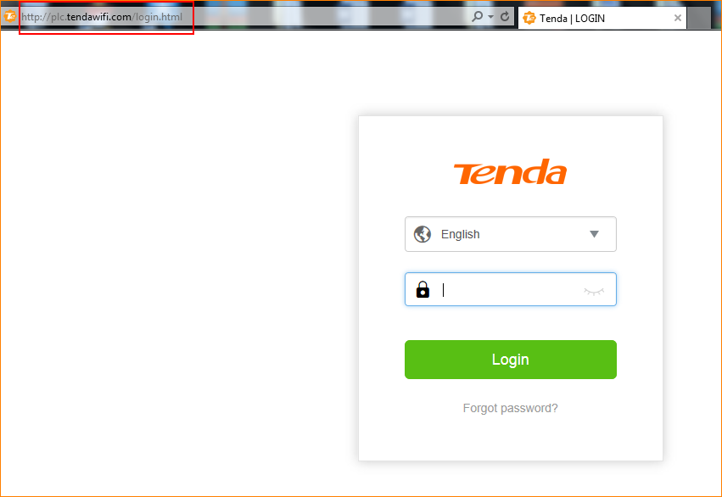
Step 2: Choose “System”
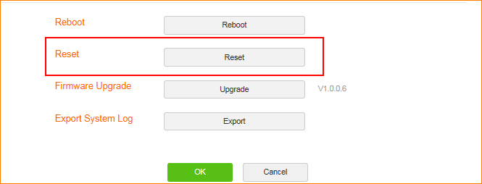
Step 3: Tap “Reset” button.
Method 2:
Step 1: Find the Reset button on the side of the PLC.
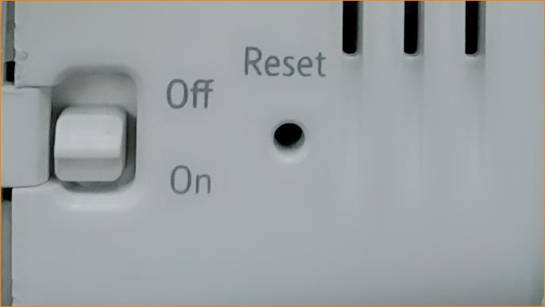
Step 2: Press the reset button for 8 seconds until all lights on and then off few seconds later.

